Task 3:
https://PKILabServer.com:4433/

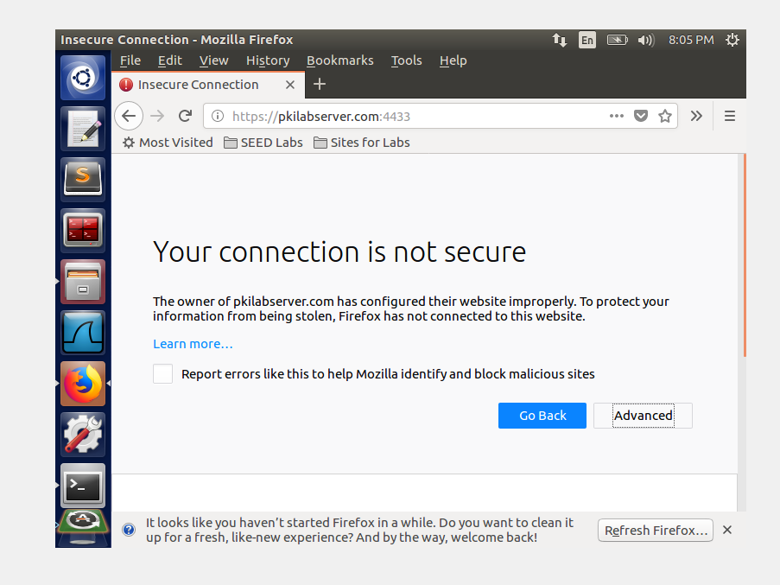
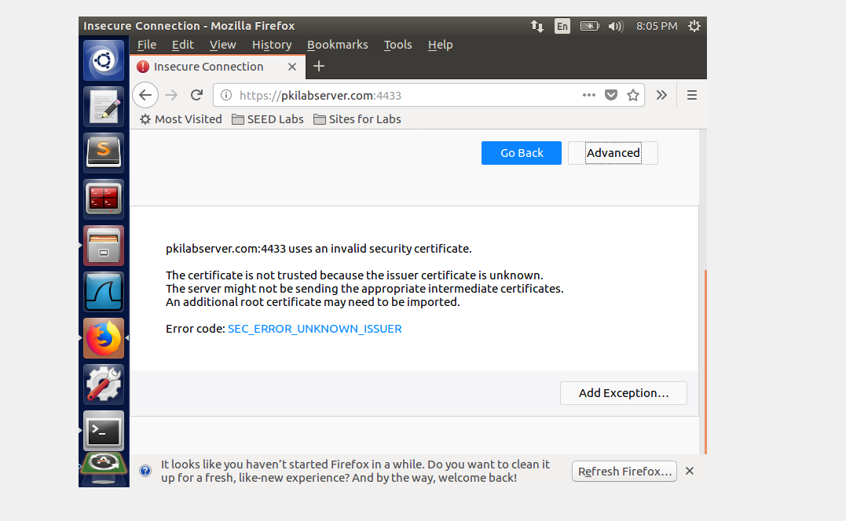

You will see a list of certificates that are already accepted by Firefox. From here, we can “import” our own certificate. Please import ca.crt, and select the following option: “Trust this CA to identify web sites”. You 4 will see that our CA’s certificate is now in Firefox’s list of the accepted certificates. Now, point the browser to https://PKILabServer.com:4433. Please describe and explain your observations:
After adding the certificate, the pkilabserver page is finally able to load.
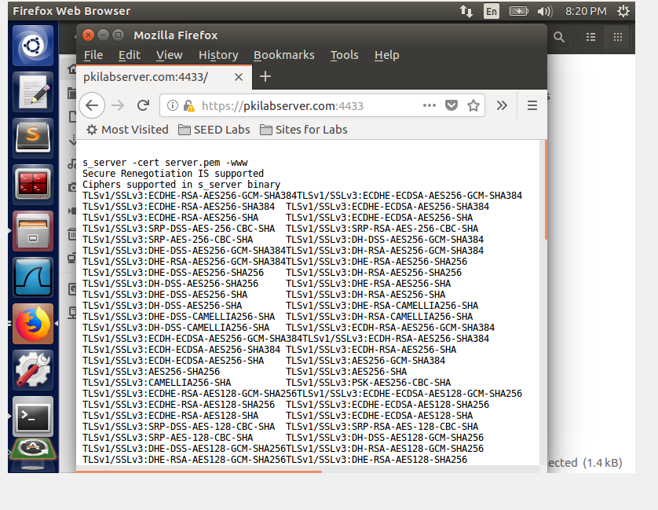

Since PKILabServer.com points to the localhost, if we use https://localhost:4433 instead, we will be connecting to the same web server. Please do so, describe and explain your observations:
Localhost produces the initial error where the website didn’t have the certificate added:
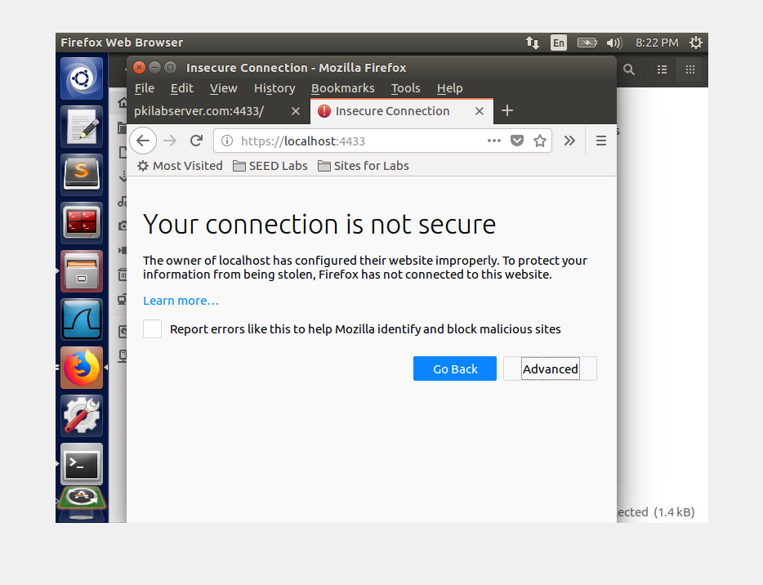

Modify a single byte of server.pem, and restart the server, and reload the URL. What happens? Describe and explain your observations. (to edit the file server.pem, you can install a hex editor called GHex using the command “sudo apt-get install ghex”; GHex will be installed as /usr/bin/ghex2).
After changing a single byte using ghex in the certificate, this is the error:
